Week – 3 : Spring Data JPA With Hibernate

Hands On 1:Spring Data JPA - Quick Example

Step 1: Create Database and Table
create database ormlearn;
use ormlearn;
create table country (
co_code varchar(2) primary key,
co_name varchar(50)
);
insert into country values ('IN', 'India');
insert into country values ('US', 'United States of America');
Step 2: Create Entity Class
Country.java
package com.cognizant.ormlearn.model;
import javax.persistence.Column;
import javax.persistence.Entity;
import javax.persistence.Id;
import javax.persistence.Table;
@Entity
@Table(name = "country")
public class Country {
@Id
@Column(name = "co_code")
private String code;
@Column(name = "co_name")
private String name;
public String getCode() {
return code;
}
public void setCode(String code) {
this.code = code;
}
public String getName() {
return name;
}
public void setName(String name) {
this.name = name;
}
@Override
public String toString() {
return "Country [code=" + code + ", name=" + name + "]";
}
}
Step 3: Create Repository
CountryRepository.java
package com.cognizant.ormlearn.repository;
import com.cognizant.ormlearn.model.Country;
import org.springframework.data.jpa.repository.JpaRepository;
import org.springframework.stereotype.Repository;
@Repository
public interface CountryRepository extends JpaRepository<Country, String> {
}
Step 4: Create Service
CountryService.java
package com.cognizant.ormlearn.service;
import com.cognizant.ormlearn.model.Country;
import com.cognizant.ormlearn.repository.CountryRepository;
import org.springframework.beans.factory.annotation.Autowired;
import org.springframework.stereotype.Service;
import org.springframework.transaction.annotation.Transactional;
import java.util.List;
@Service
public class CountryService {

@Autowired
private CountryRepository countryRepository;
@Transactional
public List<Country> getAllCountries() {
return countryRepository.findAll();
}
}
Step 5: Main Application
OrmLearnApplication.java
package com.cognizant.ormlearn;
import com.cognizant.ormlearn.model.Country;
import com.cognizant.ormlearn.service.CountryService;
import org.slf4j.Logger;
import org.slf4j.LoggerFactory;
import org.springframework.boot.SpringApplication;
import org.springframework.boot.autoconfigure.SpringBootApplication;
import org.springframework.context.ApplicationContext;
import java.util.List;
@SpringBootApplication
public class OrmLearnApplication {
private static final Logger LOGGER =
LoggerFactory.getLogger(OrmLearnApplication.class);
private static CountryService countryService;
public static void main(String[] args) {
ApplicationContext context =
SpringApplication.run(OrmLearnApplication.class, args);
countryService = context.getBean(CountryService.class);
testGetAllCountries();
}
private static void testGetAllCountries() {

LOGGER.info("Start");
List<Country> countries =
countryService.getAllCountries();
LOGGER.debug("countries={}", countries);
LOGGER.info("End");
}
}
Step 6: Configure application.properties
logging.level.org.springframework=info
logging.level.com.cognizant=debug
logging.level.org.hibernate.SQL=trace
logging.level.org.hibernate.type.descriptor.sql=trace
spring.datasource.driver-class-name=com.mysql.cj.jdbc.Driver
spring.datasource.url=jdbc:mysql://localhost:3306/ormlearn
spring.datasource.username=root
spring.datasource.password=root
spring.jpa.hibernate.ddl-auto=validate
spring.jpa.properties.hibernate.dialect=org.hibernate.dialect.MySQL5Dialect

OUTPUT:
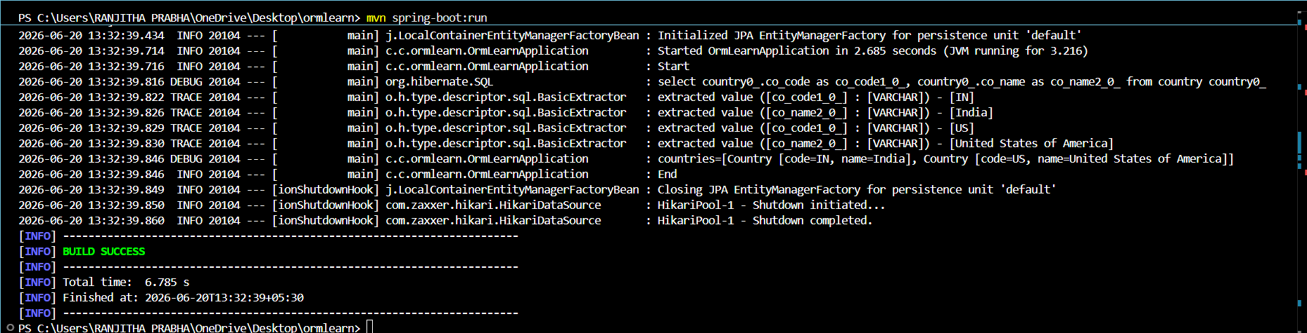

Hands On 4-Difference between JPA, Hibernate and Spring Data JPA
1. JPA (Java Persistence API)
- JPA is a Java specification used for mapping Java objects to relational database tables.
- It defines a set of interfaces and annotations that help developers perform database operations in a standard way.
- Since JPA is only a specification, it cannot perform database operations by itself and requires an implementation such as Hibernate.
Features of JPA
- Standard specification for ORM in Java.
- Defines annotations like @Entity, @Table and @Id.
- Provides portability across different ORM providers.
- Does not contain implementation code

2. Hibernate
- Hibernate is an ORM framework and one of the most popular implementations of JPA.
- It converts Java objects into database records and vice versa.
- Hibernate provides additional features beyond JPA, such as caching, lazy loading and automatic table generation.
Features of Hibernate
- Implements JPA specifications.
- Reduces manual SQL coding.
- Supports caching for better performance.
- Provides automatic schema generation.
- Can be used independently without Spring.

3. Spring Data JPA
- Spring Data JPA is a Spring Framework module that simplifies working with JPA.
- It provides repository interfaces that automatically generate database operations, reducing the amount of code developers need to write.
Features of Spring Data JPA
- Built on top of JPA.
- Provides repository interfaces such as JpaRepository.
- Generates queries based on method names.
- Reduces boilerplate code.
- Integrates seamlessly with Spring Boot.

Code Comparison
Using Hibernate (Manual Approach):
public Integer addEmployee(Employee employee) {
Session session = factory.openSession();
Transaction tx = null;
Integer employeeID = null;

try {
tx = session.beginTransaction();
employeeID = (Integer) session.save(employee);
tx.commit();
} catch (HibernateException e) {
if (tx != null)
tx.rollback();
e.printStackTrace();
}
finally {
session.close();
}
return employeeID;
}
This approach requires manually opening a session, starting a transaction, saving the entity, and handling rollback or commit.

Using Spring Data JPA : EmployeeRepository.java:
public interface EmployeeRepository extends JpaRepository<Employee, Integer>
{
}

EmployeeService.java:
@Autowired
private EmployeeRepository employeeRepository;

@Transactional
public void addEmployee(Employee employee) {
employeeRepository.save(employee)
}

In this approach, all the boilerplate code is removed. Spring handles the session, transaction, and persistence automatically.
Conclusion
JPA provides the standard rules for object-relational mapping, Hibernate implements those rules and performs the actual database operations, while Spring Data JPA makes development easier by reducing coding effort and providing ready-made repository support. Together, they help developers build efficient and maintainable database-driven applications.

